Python Worksheet #1

Basics, Variables and Expressions, Strings and Lists, Formatted Printing

Dr. Scott

CSI 500

Spring 2019

# Problem #1: Astrophysics

In the recent Ridley Scott film "The Martian", actor Matt Damon plays the role of Mark Watney, an astronaut who is accidently marooned on Mars. Astronomers have calculated that the distance from the Earth to the Sun is 1 Astronomical Units (AU), or about 149.6M KM, and the distance from Mars to the Sun is about 1.524 AU, or 227.9M KM. Radio signals travel at the speed of light, c, which is 2.998E8 m/sec.

Use Python as a scientific calculator to compute how long it would take a radio signal to travel from Mark Watney's base camp on Mars to NASA Mission Control on Earth. You may wish to visualize the problem first as shown below.

Recall from physics that distance is rate multiplied by time, or

$$rt=d$$

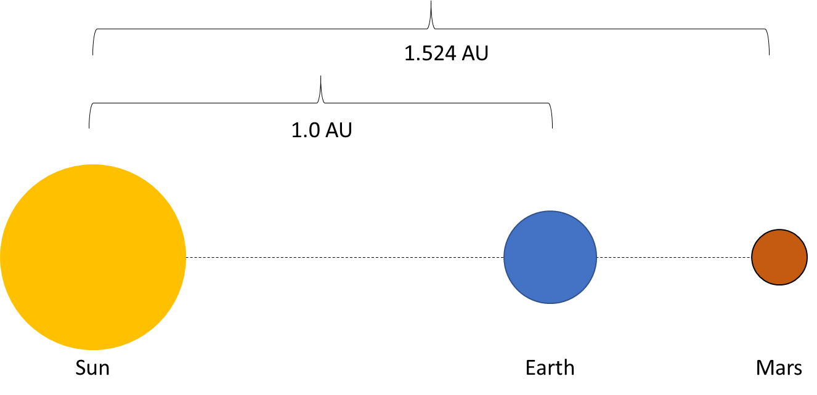

# Problem #2: Modern Art and Color Hex Codes

Mark Rothko's abstract art often features large blocks of intense colors, such as the iconic "Orange and Yellow, 1956" oil painting. Let's use our Python skills to do some technical analysis of this work.

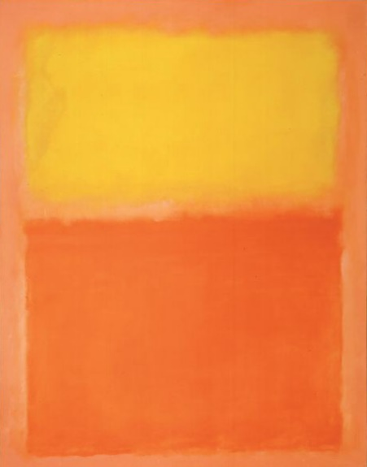

Orange and Yellow, 1956

Mark Rothko

Oil on Canvas

Reproduced for educational use under the "Fair Use" provision of the Copyright Act of 1976. WikiArt.org allows unlimited copying, distributing and displaying of the images of public domain artworks solely. We use here Copyright term based on authors' deaths according to U.S. Copyright Law, that is 70 years. In other countries, the duration of copyright term may differ. Please check here copyright length according to your country's legislation before you consider reproducing images borrowed from Wikipaintings.org. Artworks protected by copyright are supposed to be used only for contemplation. Images of that type of artworks are prohibited for copying, printing, or any kind of reproducing and communicating to public since these activities may be considered copyright infringement.

View the painting at this website: <https://www.wikiart.org/en/mark-rothko/orange-and-yellow>

If you are running Firefox, do this:

* On the tools icon in the upper right, click to Web Developer, click, then press "Eyedropper". This will open up the color selector eyedropper tool. Use the tool to hover over the upper part of the Rothko painting, and copy down the hex code for yellow being used. Now use the tool to hover over the bottom part of the painting, and copy down the hex code for the orange being used.

If you are not running Firefox, do this:

* Go to the website; <https://www.imagecolorpicker.com> .
* On the bottom right, enter in the Wikiart website you viewed above in the text box below the instructions "Use this box to get the HTML color code from a picture via his url.". Press "Take Image", and in a few seconds, the web site will appear in the upper right as a thumbnail. Use your mouse to place the crosshairs on the upper yellow part of the Rothko painting, and double click. Copy down the hex code appearing in the dialog box on the left. Now move to the bottom orange part of the painting, double click, and copy down the hex code appearing in the dialog box on the left.

Now fill out this table using your data in order to analyze the colors used in the painting. Use Python hexadecimal numbers to compute the percentage of red, green, and blue used for the Orange and Yellow blocks of color used in Rothko's painting.

**Hexadecimal Color Analysis of Mark Rothko's "Orange and Yellow, 1956"**

|  |  |  |  |  |
| --- | --- | --- | --- | --- |
| **Color** | **HTML code** | **Red percentage** | **Green percentage** | **Blue percentage** |
| Orange | F16F33 | rr/ff = 59.8% | bb/ff = 27.4% | gg/ff = 12.7% |
| Yellow | FACA3A | rr/ff = 49% | bb/ff = 39.6% | gg/ff = 11.4% |

What can you say about Rothko's choice of colors? What percentage of red, green, and blue did he use?

Orange is typically 60/40 red and green, so the orange Rothko used is a bit more bluish in hue, more similar to a color such as coral.

The yellow he used is fairly close to a yellow or light yellow, but with a bit less green than would be expected for a color labeled yellow.

Overall, he seems to have used slightly cooler versions of orange and yellow as the pigments combine to form more complex colors.

# Problem #3: String Formatting

Spam ™ is a processed meat food product that is most often marketed in small cans or "tins" (see <http://www.spam.com/> for recipes and additional information). Spam figures prominently in the 1970 Monty Python sketch of the same name, in which characters unsuccessfully attempt to order breakfast at a small restaurant.

Using your Python string processing skills, write Python expressions to accomplish the following. You may write the Python code below the question, or submit a separate Python code file (*.py) if you prefer.

* Declare a string variable and assign it the value 'spam'.
* Use the Python string operator + to create a new message that contains the string 'spam' 4 times.
* Can you think of a way to include a space character ' ' so the words are not all jumbled together?
* Use the Python string operator * to print a message that says 'spam' 4 times.
* Use the Python string operations to print 'spam' in all upper-case letters.
* Use the Python string operations to print 'spam' in the center of the page (assume the page is 72 columns wide).

# Problem #4: List processing

Continuing the Monty Python Spam sketch of Problem #3, assume that the restaurant patrons must select their choices from the following items.

* Spam
* Eggs
* Bacon
* Ham
* Muffin

Using your Python list processing skills, write Python expressions to accomplish the following. You may write the Python code below the question, or submit a separate Python code file (*.py) if you prefer.

* Write an expression to store these choices in a Python list.
* Write an expression to sort the list in alphabetical order.
* Write an expression to print out the items on the list, one per line.

Hint: remember that sorting is an "in place" operation that does not return a meaningful value.

# Problem #5: Formatted Printing

In the lectures, we discussed various ways of formatting your printed output to improve readability. Using your Python formatting skills, develop Python print expressions to accomplish the following. You may write the Python code below the question, or submit a separate Python code file (*.py) if you prefer. Use these variable declarations.

* pi_val = 3.141592654
* e_val = 2.718281828
* What happens if you print without using any special formatting?

print('the value of pi is ' + str(pi_val) + ' and the value of e is ' + str(e_val))

* What happens if you print using the "simplified" printf() formatting method we discussed in lectures?

printf('the value of pi is %8.4f, and the value of e is %8.4f', pi_val, e_val )

* What happens if you print using the standard Python 3 print formatting?

print('the value of pi is {0:8.4f}, and the value of e is {1:8.4f}'.format(pi_val, e_val) )